 | 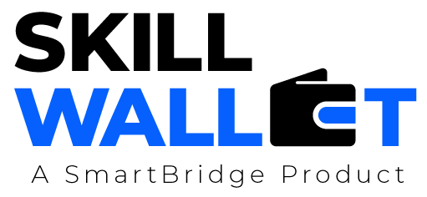
Communication
Date | 04 July 2026
Team ID
Project Name | Smart Agricultural Production Optimization Engine (OptiCrop)
Maximum Marks | 1 Mark
Communication Plan:
Effective communication is essential for a successful project demonstration. This document outlines the communication strategy used within the team and with stakeholders throughout the project lifecycle, including how updates, issues, and feedback were managed.
S.No | Communication Type | Frequency | Channel / Tool | Participants | Purpose
1 | Team Standup | Daily | WhatsApp / Google Meet | Hemanth Kumar, Gorli Uday Teja | Quick sync on daily progress and blockers
2 | Progress Update | Weekly | Email + shared Google Doc | Hemanth Kumar, Gorli Uday Teja | Track milestone progress against the project plan
3 | Issue / Bug Discussion | As Needed | WhatsApp / GitHub Issues | Hemanth Kumar, Gorli Uday Teja | Discuss and resolve technical blockers quickly
4 | Stakeholder Review | Bi-Weekly | Google Meet | Hemanth Kumar, Gorli Uday Teja (no mentor currently assigned) | Review progress internally and plan next steps
5 | Final Demo Rehearsal | Once | Google Meet / In-person | Hemanth Kumar, Gorli Uday Teja | Rehearse the live demo flow and timing before the actual presentation
6 | Post-Demo Retrospective | Once | Google Meet | Hemanth Kumar, Gorli Uday Teja | Reflect on demo feedback and plan follow-up improvements
Communication Challenges & Resolutions:
S.No | Challenge Faced | Resolution / Action Taken
1 | Coordinating schedules between the two team members, who had different class timings. | Fixed a recurring daily standup slot that worked for both members' schedules.
2 | Some early confusion over which team member owned Flask backend versus frontend tasks. | Clearly assigned module ownership in the sprint backlog (see Project Planning document).
3 | A model cold-start delay caused confusion during an early rehearsal. | Added a pre-warm step to the demo checklist so the model is loaded before any live session.

